Identification of the beneficial owner
according to the Money Laundering Act
General information:
According to the Money Laundering Act (MLA), notaries are considered as obliged entities. Therefore, they shall identify the beneficial owners of companies in certain transactions (Sec. 10, para. 1, pt. 2 of the MLA).

Beneficial owners are natural persons who, directly or indirectly (in the case of a multi-level shareholder structure), hold more than 25 % of the capital or voting shares or exercise control in a similar way (Sec. 3, para. 2 of the MLA).

The involved parties have to make information and documents required to identify the beneficial owners available (Sec. 11, para. 6 of the MLA). If they do not fulfil this obligation, they might be subject to a prohibition to authenticate which was introduced on 1 January 2020 (Sec. 10, para. 9, sentence 4 of the MLA).

Besides, since 1 January 2020, foreign companies that intend to purchase real estate in Germany have to register in the German Transparency Register or that of another EU Member; if the company has not fulfilled this obligation, the notary is mandatorily required to refuse the authentication (Sec. 10, para. 9, sentence 4 of the MLA) (see Annex 2).

In view of the above, you are kindly asked to complete this questionnaire in order to disclose information on the ownership and control structure of the company and to provide certain documents:

Information on the company:
(Company name, seat, business address)
- Can the shareholder structure of the company be derived correctly from company documents (especially articles of association or list of shareholders; excerpts from the commercial register are not sufficient)?

- Yes
Please attach the corresponding document(s) and explain if necessary
(in the case of private limited liability companies (GmbH), the notary can consult the list of shareholders in the commercial register)
- No
- Please indicate the shareholder structure (see Annex 1)

Note: If other companies hold shares of the company (= multi-level shareholder structure), their shareholder structure is to be disclosed as well; this continues to apply until only natural persons appear at the end of the corporate ownership chain. In the case of a multi-level shareholder structure, a graphical representation is recommended, see Annex.

- Do voting rights correspond to ownership?
- Yes (this is usually the case)
- No (e.g. due the agreements on voting rights, pooling agreements or incongruent voting rights)
- Please attach the corresponding document(s) and explain if necessary
(the notary can consult the articles of association of private limited liability companies (GmbH) and public limited liability companies (AG) in the commercial register)

- Are there persons or companies which, although they do not hold more than 25% of the company’s capital or voting shares or do not hold any shares at all, can substantially influence or prevent decisions of the company?
- No (this is usually the case)
- Yes (e.g. due to trust or control agreements, special or veto rights)
- Please attach the corresponding document(s) and explain if necessary
(the notary can consult the articles of association of private limited liability companies (GmbH) and public limited liability companies (AG) in the commercial register)

Further explanations:

Place and date:
Name/function of the declarant:

Annex 1 – ownership and control structure

Template for an overview of the ownership and control structure
First and last name / company  name of the shareholder | Place of residence / business  address of the shareholder | capital share | voting share

Remarks:
If other companies hold shares of the company (= multi-level shareholder structure), their ownership and control structure shall be disclosed as well; this continues to apply until only natural persons appear at the end of the shareholder structure. In the case of a multi-level shareholder structure, a graphical representation is recommended (see below).
If there is no natural person who holds directly or indirectly more than 25% of the capital or voting shares of the company or can by other means substantially influence or prevent decisions of the company, legal representatives, managing shareholders or partners of the company shall be indicated as (fictitious) economic owners.

Example for a graphical representation of ownership and control structure
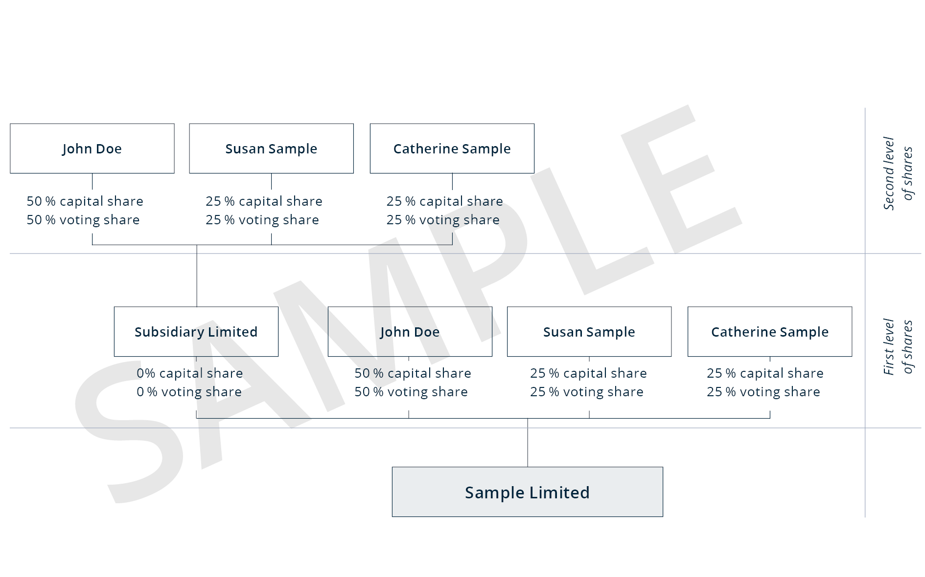

Annex 2 – Real estate acquisition by foreign companies

Obligation of registration

If a company, which has its registered office abroad, undertakes to acquire ownership of real estate located in Germany, it is obliged to provide the German Transparency Register with certain information on the beneficial owner for registration (Sec. 20, para. 1, sentence 2 of the MLA). It is sufficient, if this information has already been transmitted to another transparency register of a Member State of the European Union. As long as the company has not complied with this obligation, the notary is mandatorily required to refuse the authentication (Sec. 10, para. 9, sentence 4 of the MLA).

Mandatory information

The Transparency Register must be provided with the following information of the beneficial owners (Sec. 19, para. 1 of the MLA):

• First and last name

• Date of birth

• Place of residence

• Nature and scope of the economic interest

• Nationality

Further information

For further information on the German Transparency Register as well as on the registration and transmission of information about beneficial owners, see https://www.transparenzregister.de/treg/en/start?1
(the website is available in English as well).

For further information on the Transparency Register, see https://www.transparenzregister.de.

